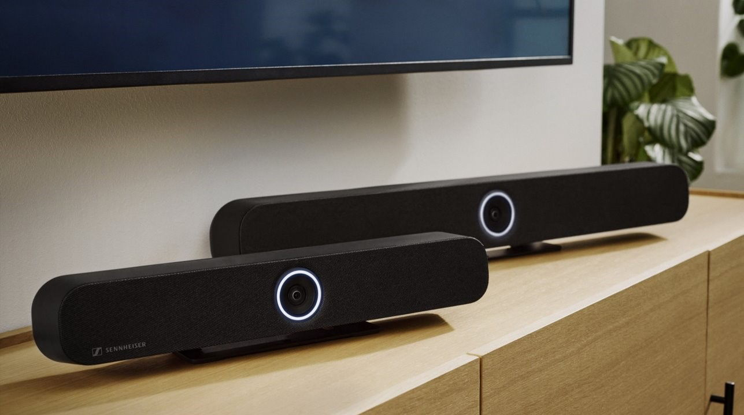
Sennheiser TeamConnect Bars Now Available
The Award-Winning All-In-One Video Conferencing Bars Deliver Sennheiser’s Premium Quality For Small to Large Meeting Spaces

OLD LYME, Conn. — June 12, 2024 — Sennheiser, the first choice for advanced audio technology that makes collaboration and learning easier, is now shipping its TeamConnect Bars (TC Bars). Part of the company’s renowned TeamConnect Family, the TC Bars are the most feature-rich, all-in-one conferencing devices in their class. The solution is available in two models depending on the meeting room size — TC Bar S and TeamConnect Bar M, scaling to the largest meeting rooms campus-wide. The TC Bar S features four microphones and two speakers, while the TeamConnect Bar M features six microphones and four speakers. Both models deliver Trusted Sennheiser Audio Quality to every meeting, ensuring attendees never miss a word.

“For years our customers have been asking us to offer Sennheiser’s trusted quality in an all-in-one video conferencing solution, but we never imagined how much excitement the announcement of the TC Bar would generate,” said Jeffrey Horan, Global PR/Media Manager for Business Communications at Sennheiser. “We’re thrilled to say: The anticipation is over. The TC Bars are available now!”

The Sennheiser TC Bars are plug-and-play devices, meaning quick set-up via USB cable. The integrated beamforming technology is the same technology found in the Sennheiser trusted TeamConnect Ceiling solutions, providing freedom of movement and seamless transition among presenters. As the first camera offering from Sennheiser, the company ensured high video quality with a 4K Ultra HD camera equipped with advanced AI features that includes autoframing and person tiling. The full-range stereo speakers provide natural speech and outstanding intelligibility.
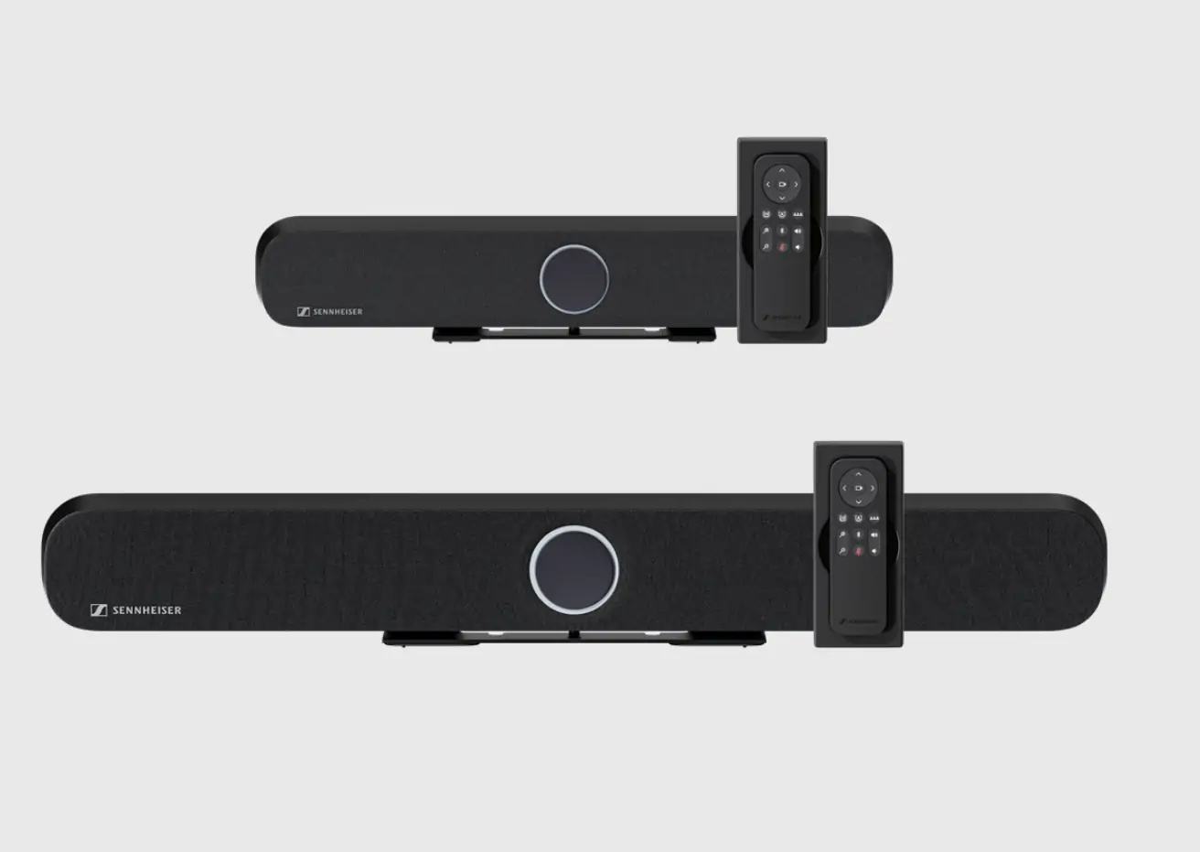

Additionally, the TC Bars provide flexible and scalable room setups with an onboard Dante port for extension mics and an option to add an external USB camera, catering to rooms requiring broader coverage. They are easy to integrate with features that include multiple mounting options; built-in remote management via Sennheiser Control Cockpit; brand-agnostic integration with leading control system and video conferencing platforms; and advanced security with encrypted control communication and password protection.

With the recent availability of the Sennheiser TeamConnect (TC) Bar Solutions, the company continues to build on its collaborations supporting seamless user experiences. Both TC Bar products integrate seamlessly with your favorite meeting platforms and are certified for Microsoft Teams (desktop applications and Teams Rooms) and Zoom (desktop applications and Zoom Rooms).

For wireless collaboration, the TC Bars have been tested and certified with Airtame, Barco, and Crestron AirMedia. Third-party plug-ins that enable easy control and integration are available for Crestron, Extron, Lightware, and Q-SYS, and can be found here for TC Bar M and here for TC Bar S. Additionally, bundles with Lenovo and MAXHUB compute and controllers offer a compelling solution for Microsoft Teams and Zoom Room environments.

For more information about Sennheiser and its solutions, visit www.sennheiser.com

About the Sennheiser brand
We live and breathe audio. We are driven by the passion to create audio solutions that make a difference. Building the future of audio and bringing remarkable sound experiences to our customers – this is what the Sennheiser brand has represented for more than 75 years. While professional audio solutions such as microphones, meeting solutions, streaming technologies and monitoring systems are part of the business of Sennheiser electronic GmbH & Co. KG, the business with consumer devices such as headphones, soundbars and speech-enhanced hearables is operated by Sonova Holding AG under the license of Sennheiser.

www.sennheiser.com
www.sennheiser-hearing.com

Local Press Contacts:
Kirsten Spruch
kirsten.spruch@sennheiser.com
+1 (860) 598-7484

InGear
Peter Schuyler
peter@ingearpr.com
+1 917-496-8970

Global Press Contact
Jeff Horan
jeffrey.horan@sennheiser.com
+1 860-598-7539

